**Lab Exercise 3–Provisioning an EC2 Instance on AWS**

Prerequisites: Terraform Installed: Make sure you have Terraform installed on your machine. Follow the official installation guide if needed. AWS Credentials: Ensure you have AWS credentials (Access Key ID and Secret Access Key) configured. You can set them up using the AWS CLI or by setting environment variables.

Exercise Steps:

**Step 1: Create a New Directory: Create a new directory for your Terraform configuration:**

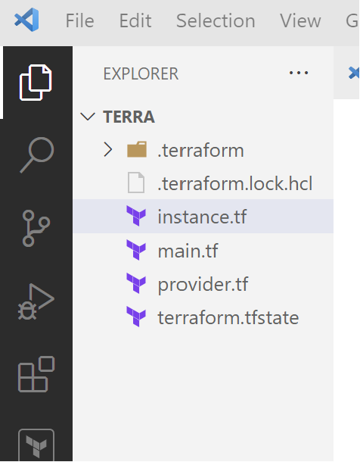

**Step 2: Create Terraform Configuration File (main.tf): Create a file named main.tf with the following content:**

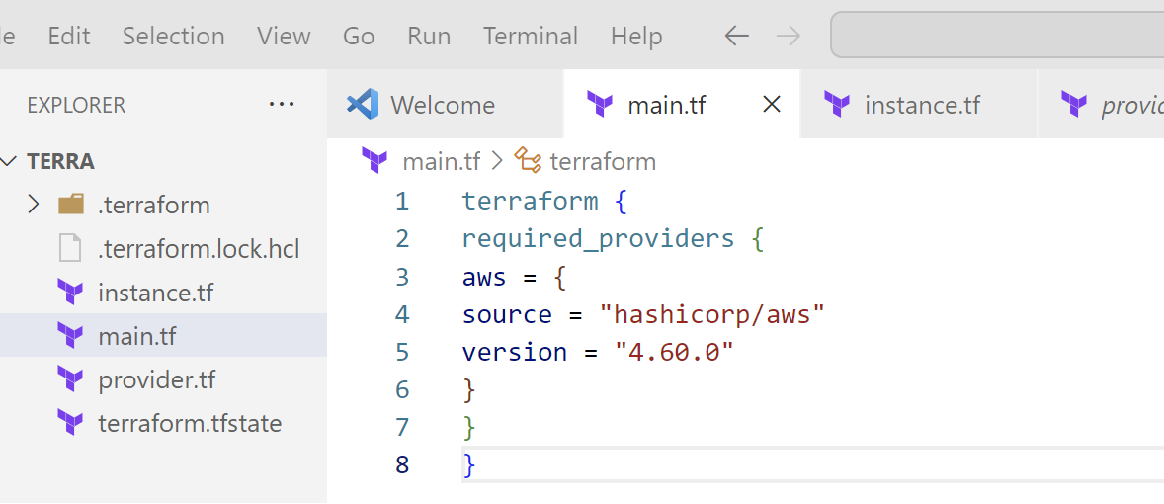

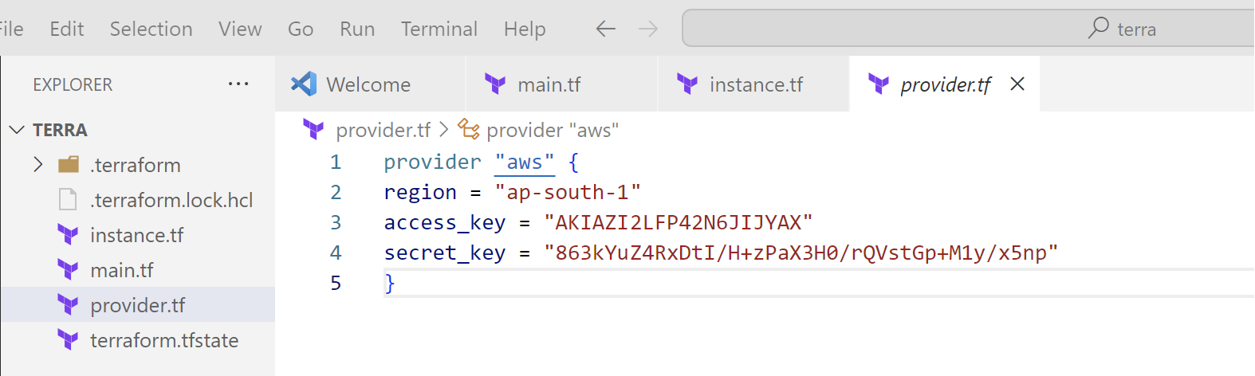

This script defines an AWS provider and provisions an EC2 instance.

**Step 3: Initialize Terraform: Run the following command to initialize your Terraform working directory:**

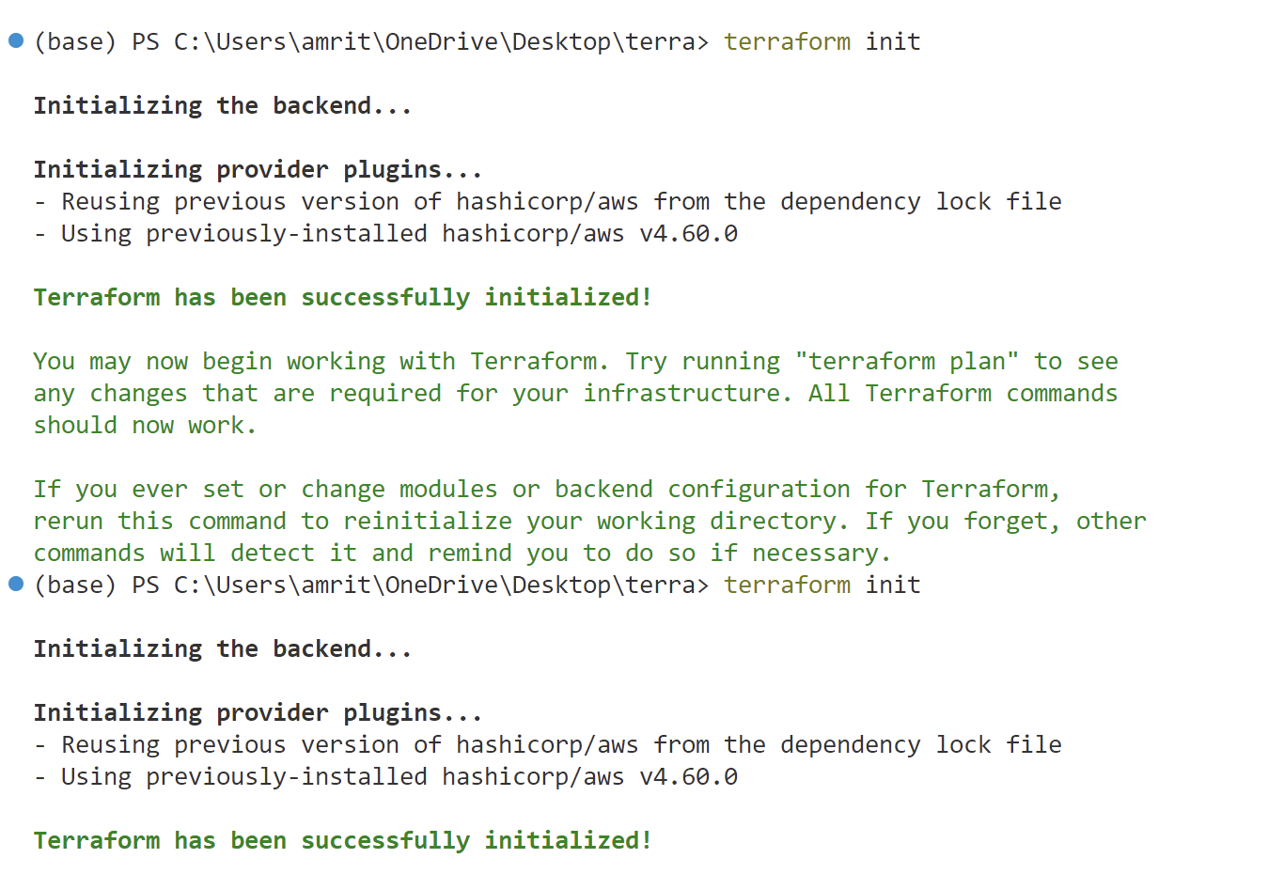

**Step 4: Create Terraform Configuration File for EC2 instance (instance.tf): Create a file named instnace.tf with the following content:**

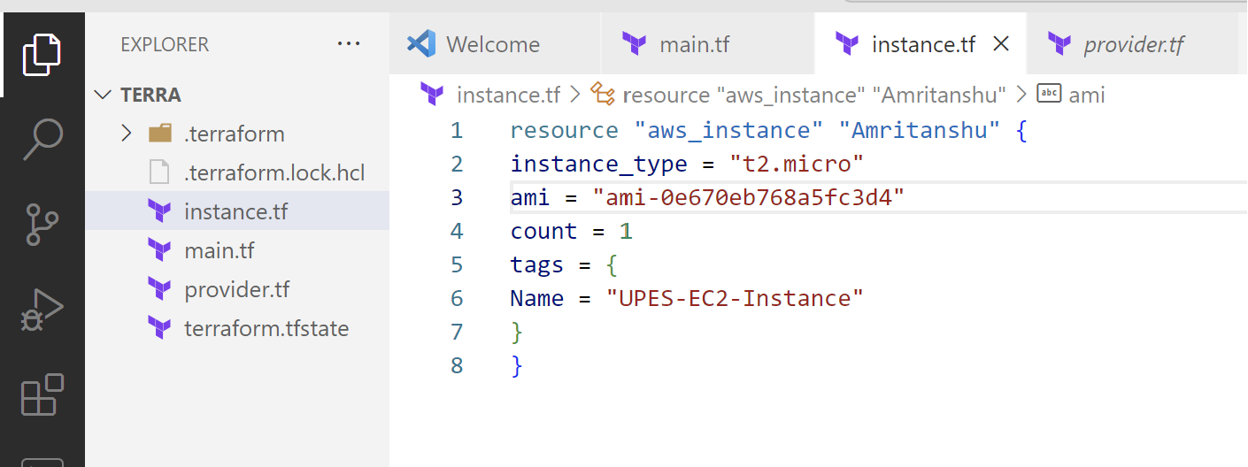

**Step 5: Review Plan:**

Run the following command to see what Terraform will do:

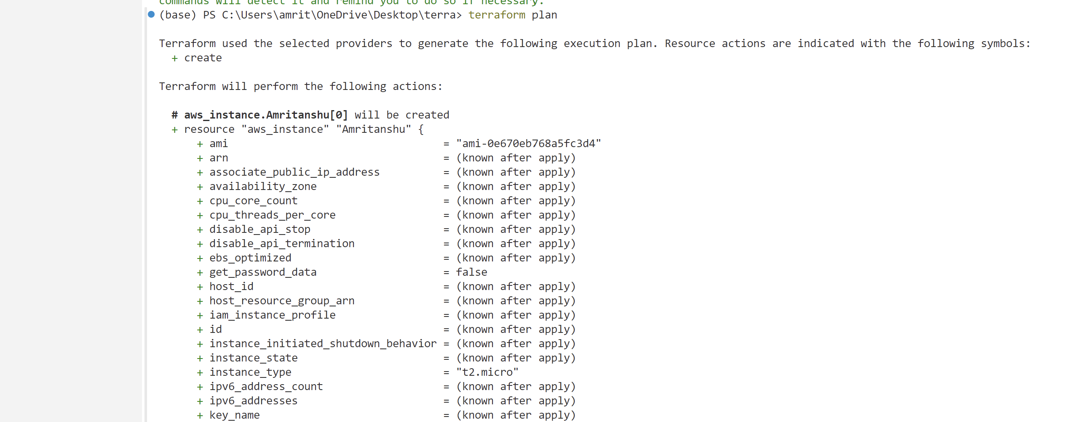

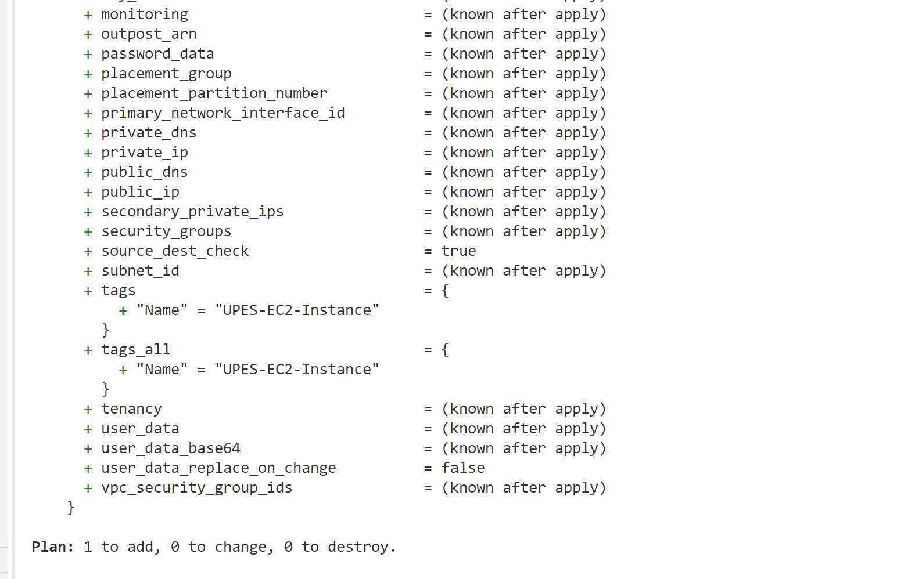

**Step 6: Apply Changes:**

Apply the changes to create the AWS resources:

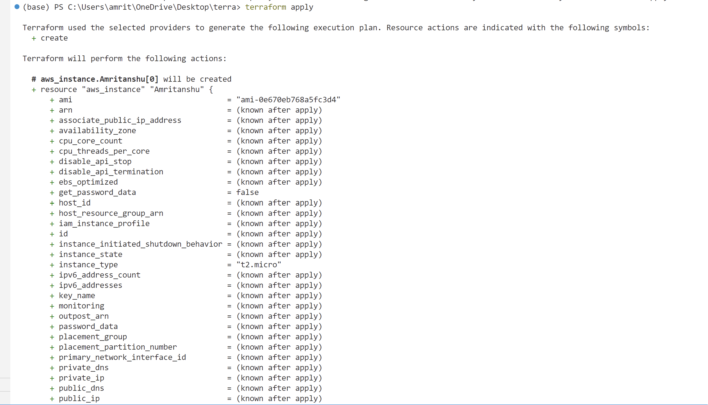

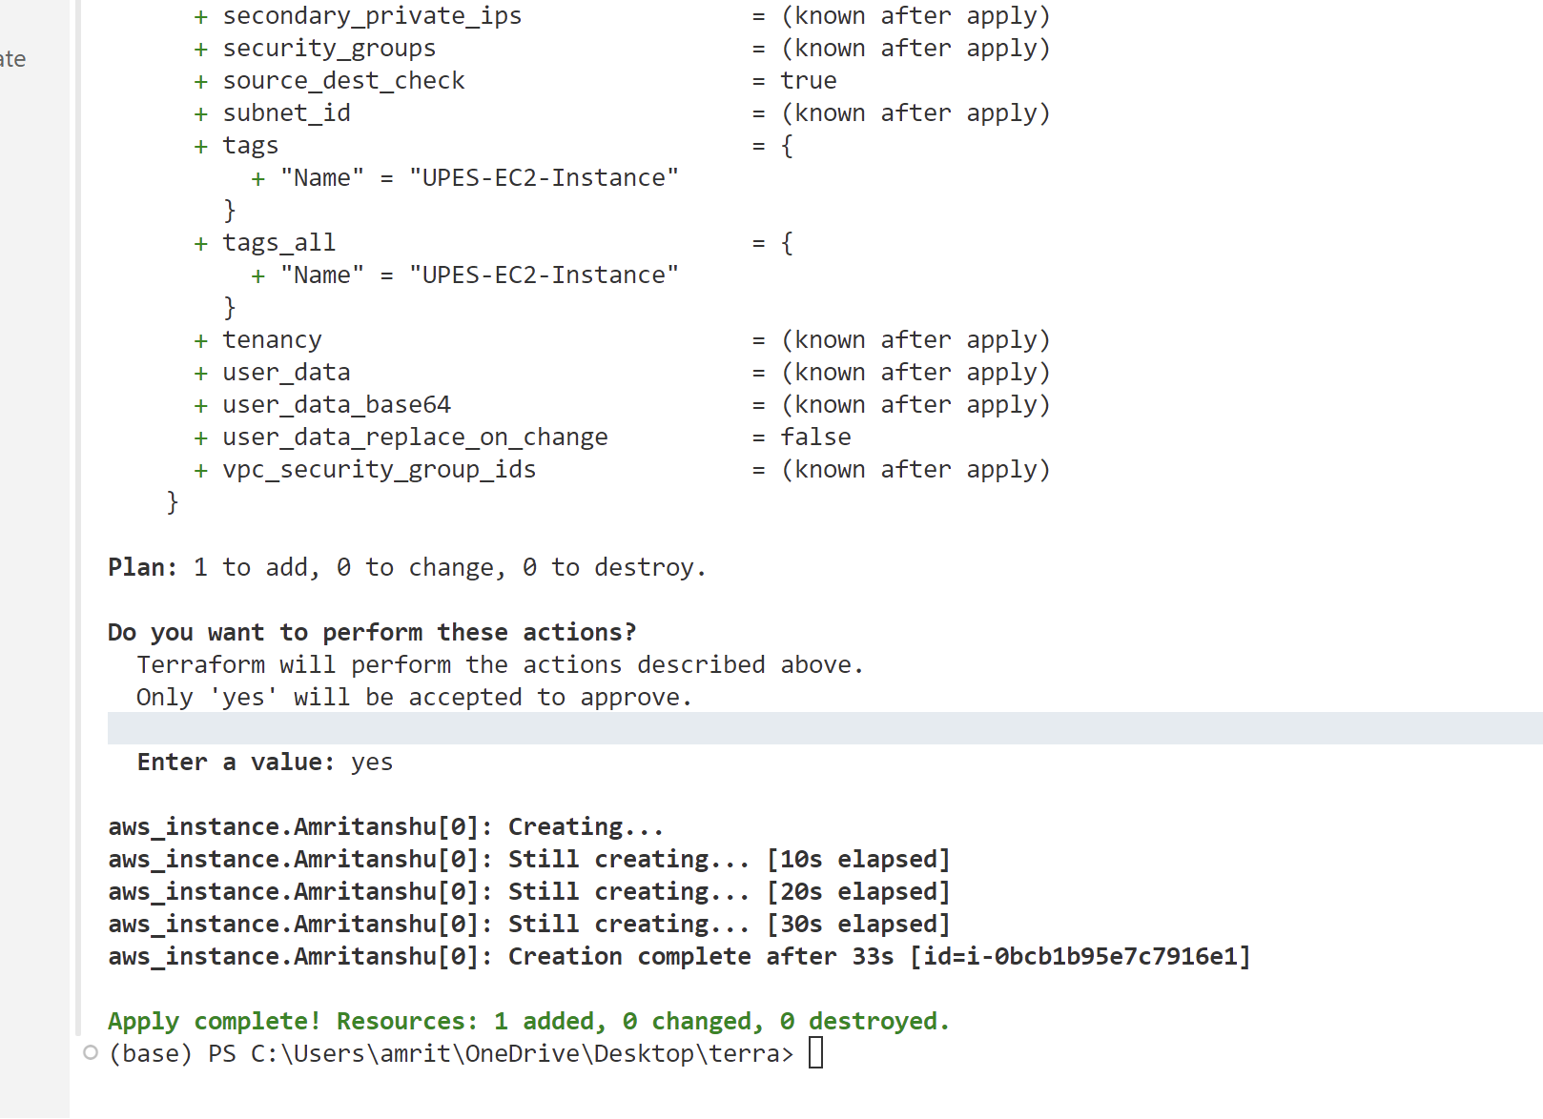

**Step 7: Verify Resources:**

After the terraform apply command completes, log in to your AWS Management Console and navigate to the EC2 dashboard. Verify that the EC2 instance has been created.

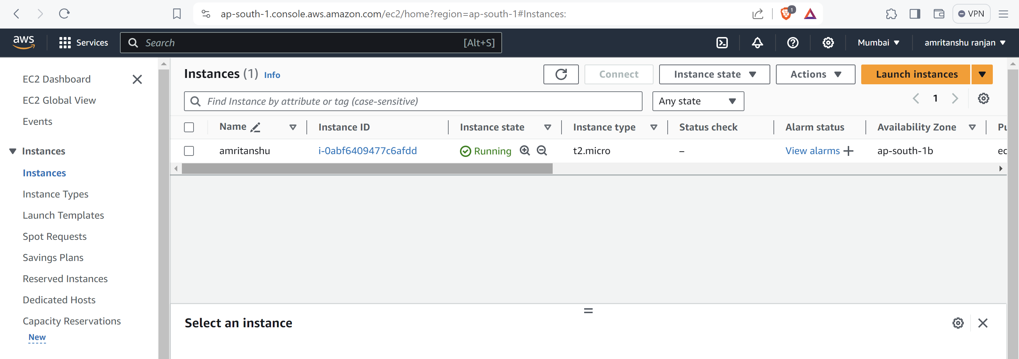

**Step 8: Cleanup Resources:**

When you are done experimenting, run the following command to destroy the created resources:

